**D.J.SANGHVI COLLEGE OF ENGINEERING**

INDUSTRIAL SUMMER TRAINING PROGRAMME

Project: To glow the led of a a particular intensity using UART (Serial communication )

By: Vatsal Makani

**Execution summary**

This project intends to glow the led having a particular intensity specified by the user.

**Step 1: Project specification**

In this project the led glows with a particular intensity as given by the user using serial communication and using PSOC.

We can use the UART any time a compatible asynchronous communications interface is required.

The data is send and received through software called as ‘Brays Terminal’.

PWM is also used to glow the led of a given intensity.

**Step 2: Component Selection**

1. UART

2. Logic zero

3. PWM

4. Clock working at 12MHz.

**Step 3: Pin configuration:**

1. Led is connected to pin p1[6]. It is for red

Led can be red, green or blue.

Different colours can be selected by connecting the led to different pins (p0[3] or p0[2]).

2. With the help of the external wire connect the Rx terminal of UART to the pin 4 of the port 0 of the psoc3 and the Tx terminal of the UART to the pin 5 of the port 0 of the psoc3.

P 12.6 (Rx) – P 0[5] (Tx)

P 12.7 (Tx) – P 0[4] (Rx)

3. Output of the PWM is connected to the led.

4. Logic zero is connected to the reset of UART and PWM.

5. Clock is given to the clock of the PWM.

Clock is working at 10MHz with tolerance +5 to -5%

**Step 4: Components configuration:**

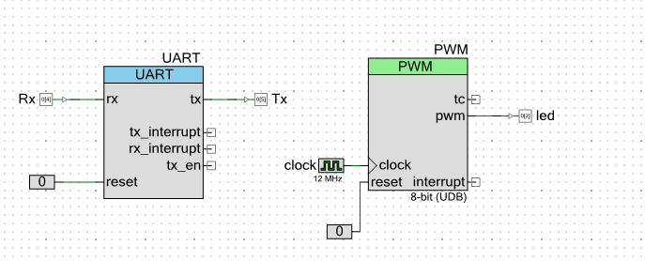

1..Uart configuration:

It is working in full UART(Tx+Rx) mode.

Data bits is set to 8 bits.

It consists of 1 stop bit.

Baud rate is set to 9600.

It has an internal clock.

2. PWM configuration:

It is operated at 1 output.

Its resolution is of 8 bits.

Therefore its period is 255.

Its compare value is set to 127.

3. Led configuration:

Led is connected to the output of the PWM.

Drive mode: strong drive.

Initial state is high. It Is hardware connected.

**Step 5: Algorithm**

1. Connect the psoc board to the computer through the usb.

2. Open the Bray’s Terminal software and rescan. Then select the port connect it.

3. write the code in main.c. include the necessary header files.

4. Start the PWM, clock, UART.

5. Send the value i.e the intensity through the bayes terminal.

6. The led is glown depending upon the intensity.

Code:

#include <project.h>

#include <cypins.h>

int main()

{

uint8 buff;

uint8 colour;

CyGlobalIntEnable;

UART_Start();

clock_Start();

PWM_Start();

PWM_WriteCompare(0);

for(;;)

{

buff = UART_GetChar(); //get the value of the intensity

if(buff>0)

{

PWM_WriteCompare(buff); // Writes the compare value when the instance is

defined as Dither mode, Center Align mode or

One Output mode.

Glows the led of given intens

}

}

}

When the value is transmitted through the Brays terminal it is stored in hex format.

In order to send the data directly in hex format it is send as $Hex_value.

Example : $FF

**Step 6: Test and debug**

1. In order to see whether the UART is working or not we can send a value and write a program that it increments the value by one and return it back. Hence we come to know whether the UART is working or not.

2. The project designed was tested and was successfully implemented.